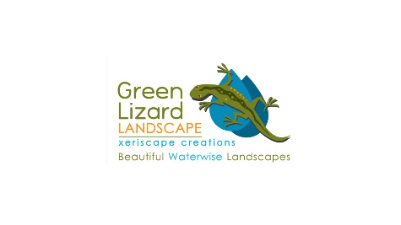
Contractor Comparison Chart

Category | Green Lizard Landscape | Second Contractor | Third Contractor
Number of years in business | 17 years in 2023
Licensed Nevada Landscape Contractor  Nevada requires a contractor to hold a C-10 license | NV-#64835
Licensed Nevada Paver Contractor.  To install over 400 square feet of pavers in Nevada, a contractor must hold a C-18 license. | NV-#87655
ISA Certified Arborist on Staff | WE-7779A
A+ rating from the Better Business Bureau | Accredited since 2008
Warranty | One year on all materials
Focused on water conservation | In our desert climate, we must conserve water, which is why we specialize in xeriscaping.
A custom, printed plan and estimate designed to your yard and goals with specific plants, paver types, and groundcovers for your review. | We want you to know what your yard will look like right from the start.

